Laporan Praktikum Sesi 5 – RIP

Nama: Bryan Orville Audric

NIM: 2602160750

Hal pertama yang dilakukan adalah mengsetting IP Address pada semua komponen (PC, router)

**Operational**

Network Address - 192.168.8.0/24

Subnet Mask – 255.255.255.0

Gateway – 192.168.8.1/24

Subnet Mask – 255.255.255.0

Operational PC-1

Host ID – 192.168.8.2/24

Subnet Mask – 255.255.255.0

Operational PC-2

Host ID – 192.168.8.3/24

Subnet Mask – 255.255.255.0

**Marketing**

Network Address - 192.168.16.0/25

Subnet Mask – 255.255.255.128

Gateway – 192.168.16.1/25

Subnet Mask – 255.255.255.128

Marketing PC-1

Host ID – 192.168.16.2/25

Subnet Mask – 255.255.255.128

Marketing PC-2

Host ID – 192.168.16.3/25

Subnet Mask – 255.255.255.128

**Designer**

Network Address - 192.168.24.0/25

Subnet Mask – 255.255.255.128

Gateway – 192.168.24.1/25

Subnet Mask – 255.255.255.128

Designer PC-1

Host ID – 192.168.24.2/25

Subnet Mask – 255.255.255.128

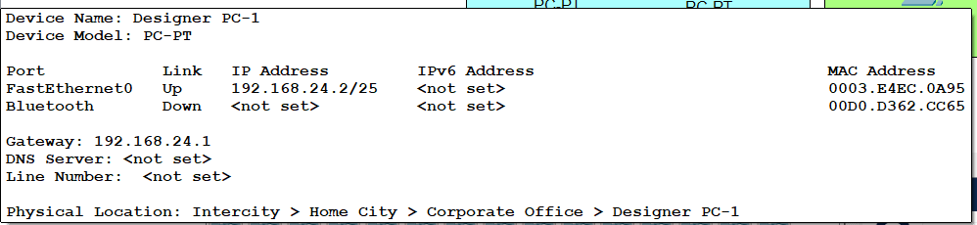

Designer PC-2

Host ID – 192.168.24.3/25

Subnet Mask – 255.255.255.128

**Administrator**

Network Address - 192.168.32.0/26

Subnet Mask – 255.255.255.192

Gateway – 192.168.32.1/26

Subnet Mask – 255.255.255.192

Administrator PC-1

Host ID – 192.168.32.2/26

Subnet Mask – 255.255.255.192

Administrator PC-2

Host ID – 192.168.32.3/26

Subnet Mask – 255.255.255.192

**First Floor Router**

Mengsetting IP pada Serial2/0 dengan 192.168.100.33/27

Subnet Mask: 255.255.255.224

**Second Floor Router**

Mengsetting IP pada Serial2/0 dengan 192.168.100.34/27

Subnet Mask: 255.255.255.224

Mengsetting IP pada Serial3/0 dengan 192.168.200.33/27

Subnet Mask: 255.255.255.224

**Third Floor Router**

Mengsetting IP pada Serial2/0 dengan 192.168.200.34/27

Subnet Mask: 255.255.255.224

**Konfigurasi RIP untuk First Floor Router**

Network yang terhubung dengan router ini adalah

192.168.8.0/24

255.255.255.0

192.168.100.32/27

255.255.255.224

**Konfigurasi RIP untuk Second Floor Router**

Network yang terhubung dengan router ini adalah

192.168.16.0/25

255.255.255.128

192.168.24.0/25

255.255.255.128

192.168.100.32/27

255.255.255.224

192.168.200.32/27

255.255.255.224

**Konfigurasi RIP untuk Third Floor Router**

Network yang terhubung dengan router ini adalah

192.168.32.0/26

255.255.255.192

192.168.200.32/27

255.255.255.224

